

A Report on Toll management

(Project 1 – using C language)

Course code – SWE 231

By

Md. Abu Hosen Shawon

ID – 161-35-1420

Kamruzzaman

ID – 161-35-1559

Department of Software Engineering

Daffodil International University

Under the supervision of

Dr. MD Moinul Islam

ASSISTANT Professor, Department of

Software Engineering

Daffodil International University

Acknowledgement

We heartily thank,

Lord Almighty for his blessing & granting us patience

And our project supervisor,

**Dr.Md. Moinul Islam** for his guidance & directions

And, our dearest parents & beloved friends for their unconditional support & strong faith upon us

We also thank for our parents that keep enlighting everyday with their wisdom and support us both mentally and financially.

Contents

1. Introduction

* Overview

* Background & motivation

* Objectives

1. Use-case diagram for toll management of a Bridge.
2. Project description.

* Running software

* Main menu

* Result of the project

1. Upcoming updates.
2. Conclusion.

References

Appendix 1: implementation code of the project.

**Introduction**

*Overview*

This project can be used for toll management system of a bridge, where they can make their users motivated to give new features all time.

This is feature the telecommunication company will offer their customers.

**Background & motivation**

Using toll management system on Podma bridge we can collect all the toll of bus,car,truck & many other.

What pushed this project is our country doesn’t have any digital toll collecting system. By this we can collect toll any time without any muscle power.

This program also save the time. For this we support all car woner and driver.

**Objectives**

This service works with all kinds of bridge toll management system. By this we can receive all kinds of bridge toll.

**The use case diagram**

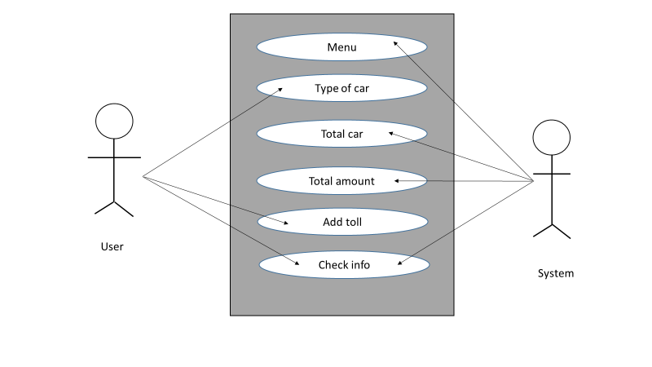

**Project description**

**Running software**

After opening this Program, there is a welcome message which says “Welcome to Toll-management system”. Underneath the message, then you see enter the car number & size of cars .Then you access after you giving the fight directions.

**Main menu**

Before you see this menu you have press any key to log in .Then you show the menu of car, select car & add to toll this car.

* + Start program
  + Password
  + Menu of car
  + Car type and amount
  + Select car
  + Add toll
  + Check info
  + Toll the car
  + Total toll & car
  + Exit.
* Start program

If you choose this option you will be promoted to the main menu of program. The program will take the value of database showing you the program inside that database.Then the program start.

* Password

In this function we have to entering password, if password is incorrect program cannot be open.

* Menu of car

This is the menu of car toll. Where this option will come effectively.

We already now your car so you will enter the amount and size of the car.

Upcoming confirmation showing you next step.

* Car type & amount

There are three type of car light, medium, easy. Those three type of car caries three type of amount. If we press medium the amount will be 100tk & this process continued for all types of cars.

* Select car
* To select a car you have to select press 1, 2 or 3. Otherwise press 0 to exit.
* Toll added for light car
* Toll added for medium car
* Toll added for heavy car
* Add toll

In this option we have to add the toll for the cars. Then the process will continued.

* Check info

There will be no information about check info but our system automatically check all the toll information of the car.

* Toll the car

This is the final option of our project. In this option we can see the total number of the car & total amount of the car. Then we have to easily collect toll of the all car. That’s why our system work perfectly.

* Total toll & car

This function shows total numbers of car & total toll.

* Exit

This where we exit the program, if you don’t want to exit then click 1, 2 or 3. Otherwise press 0 to exit.

Result of the project

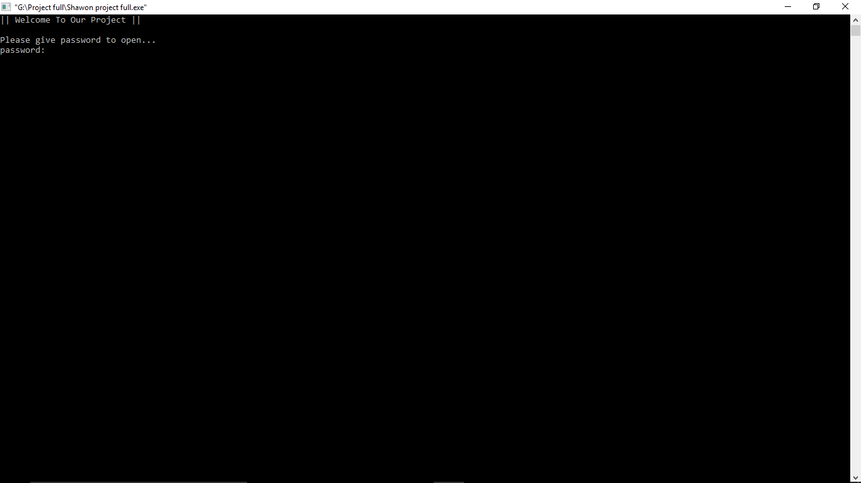

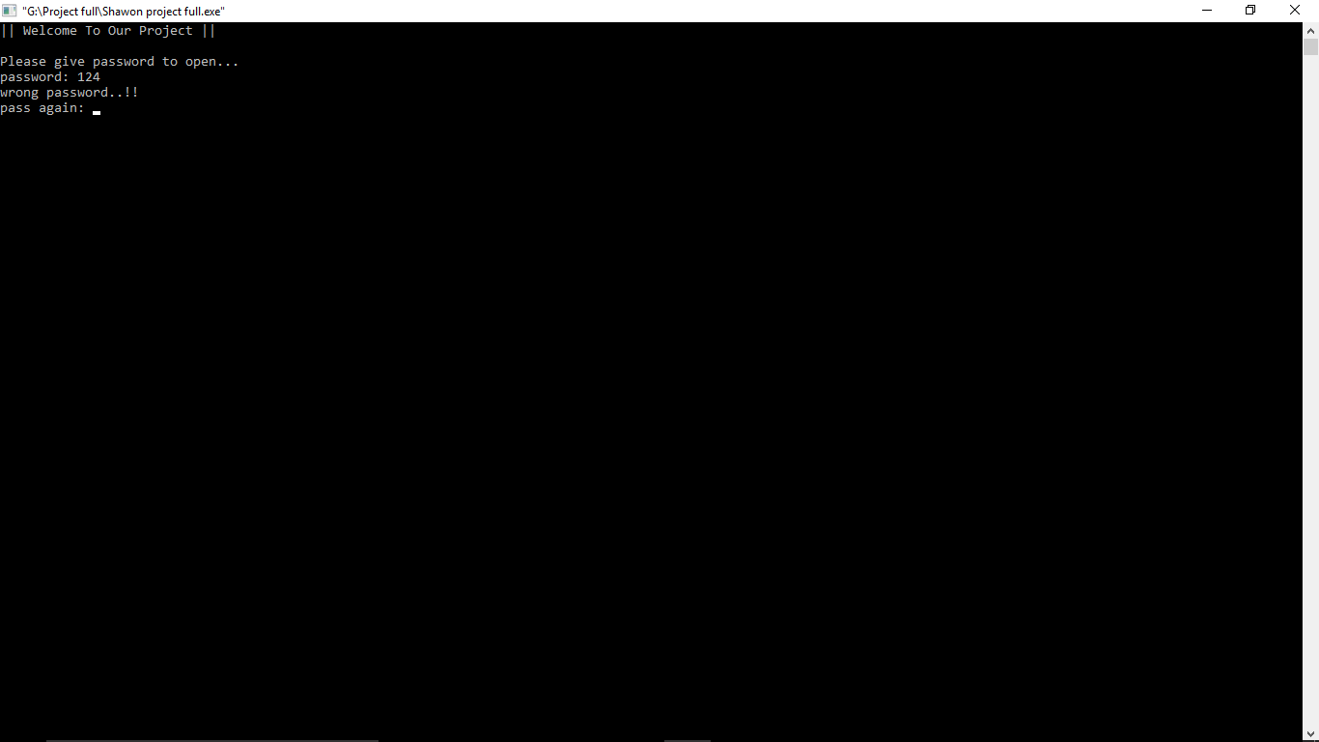

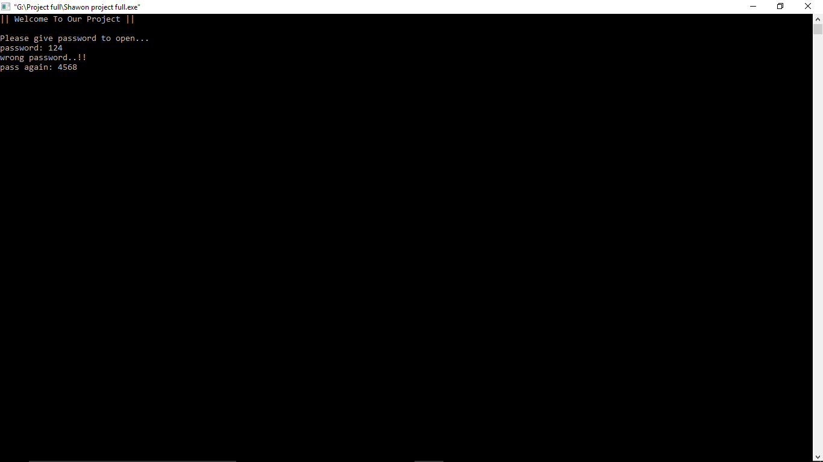

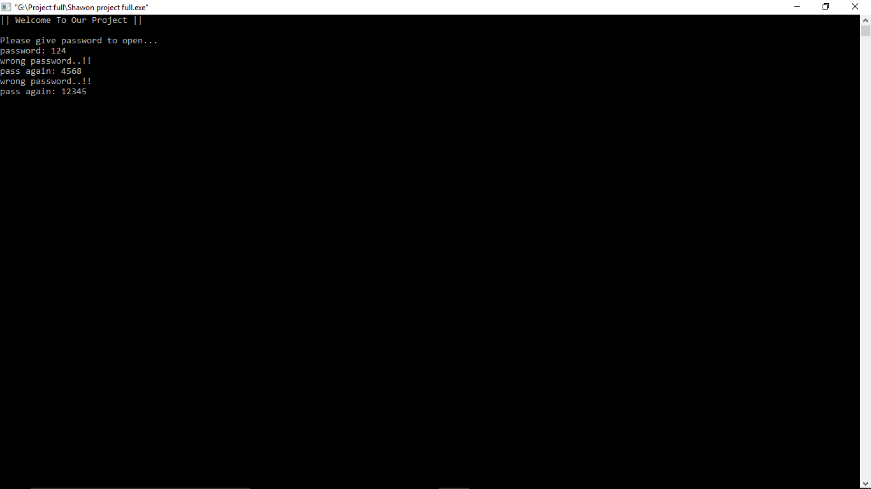

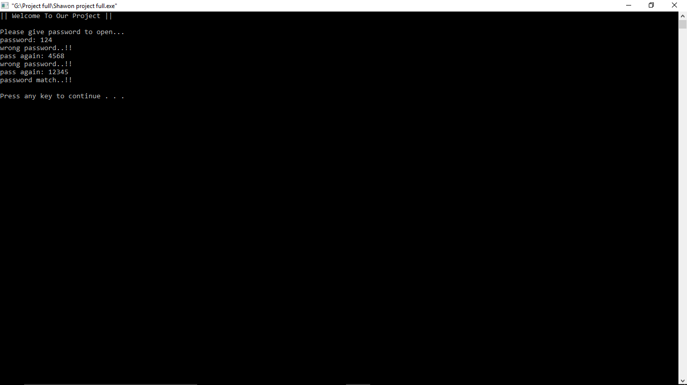

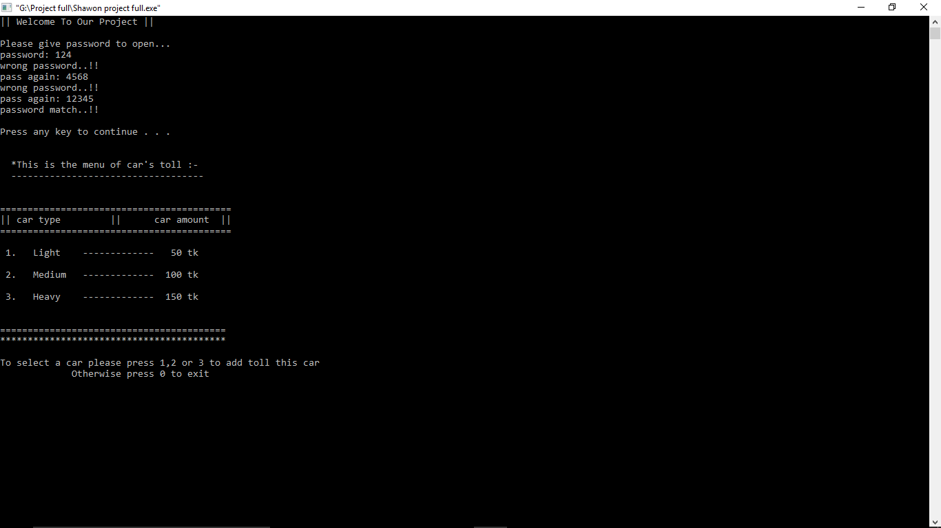

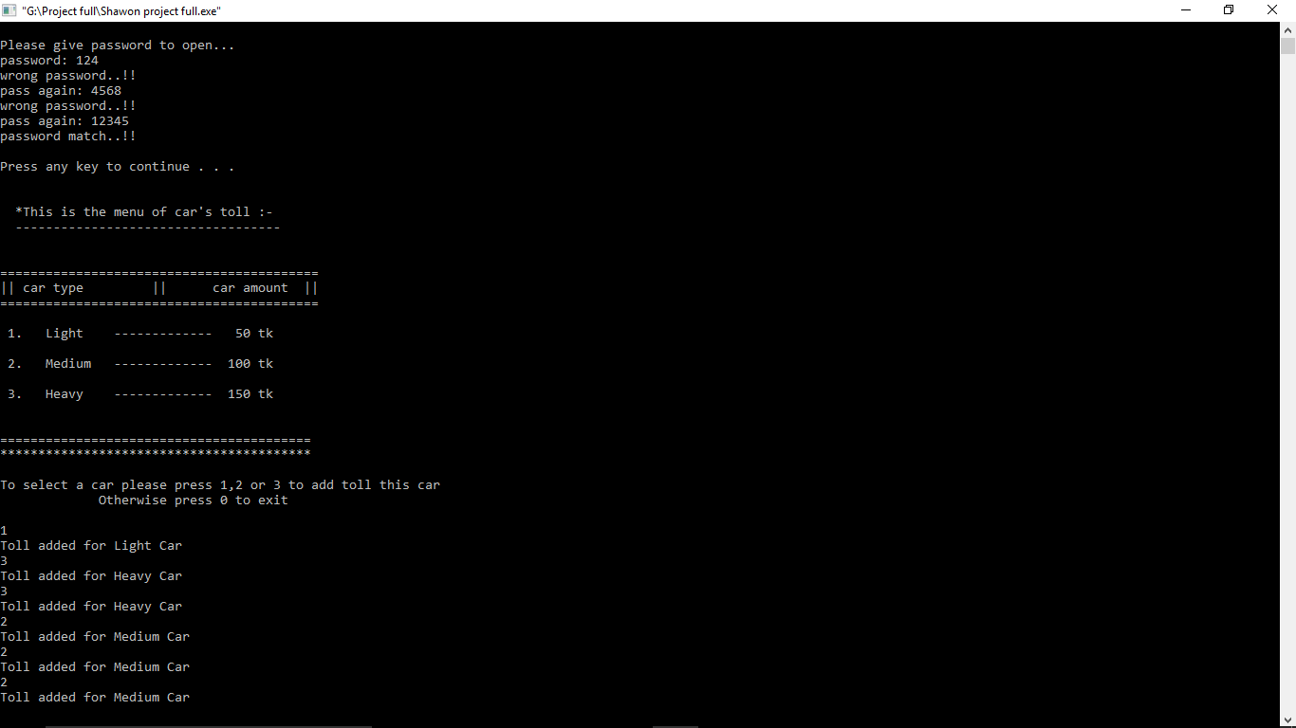

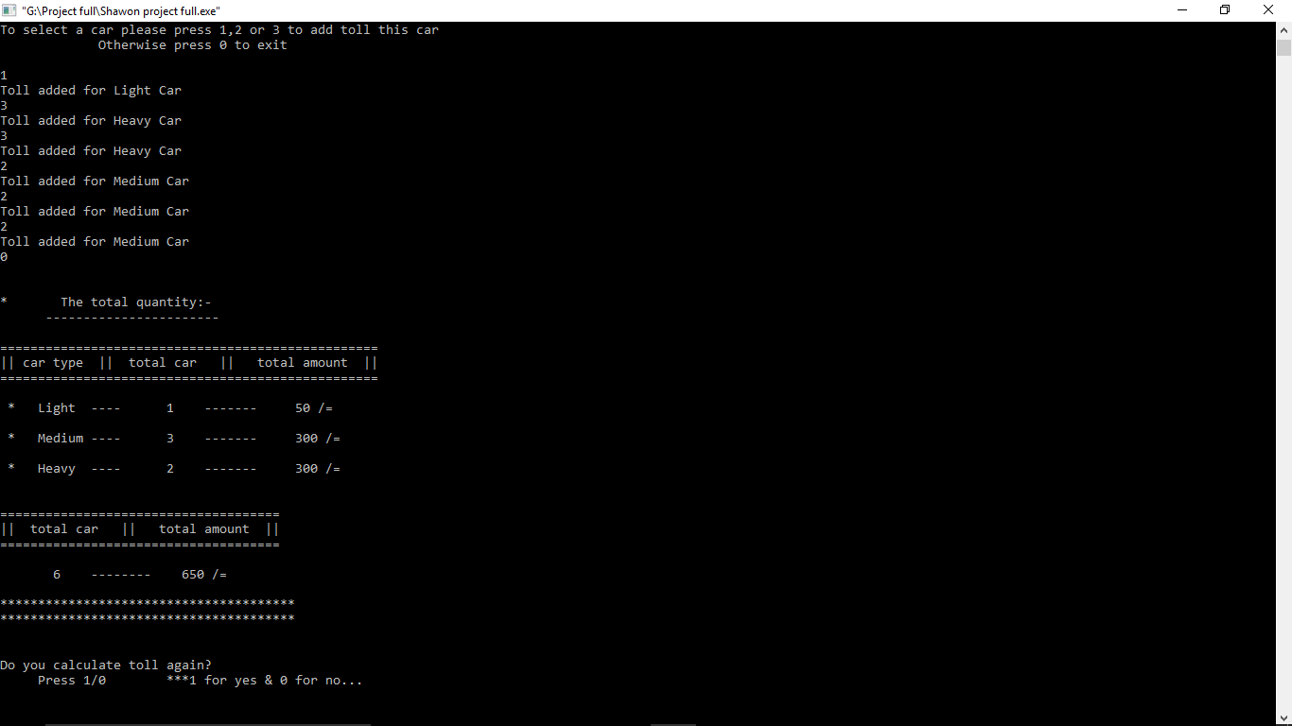

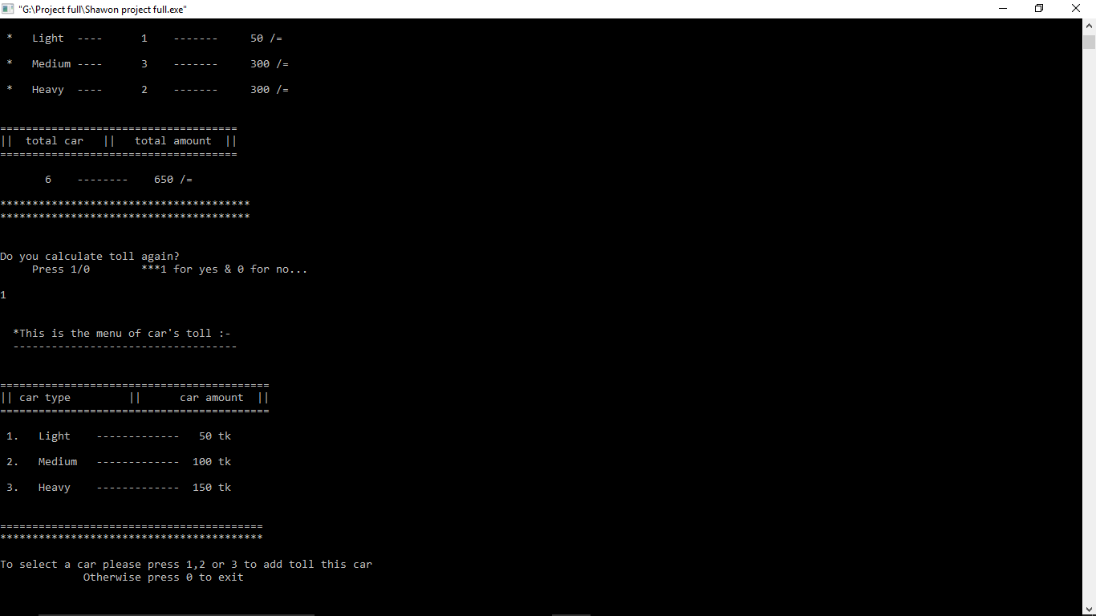

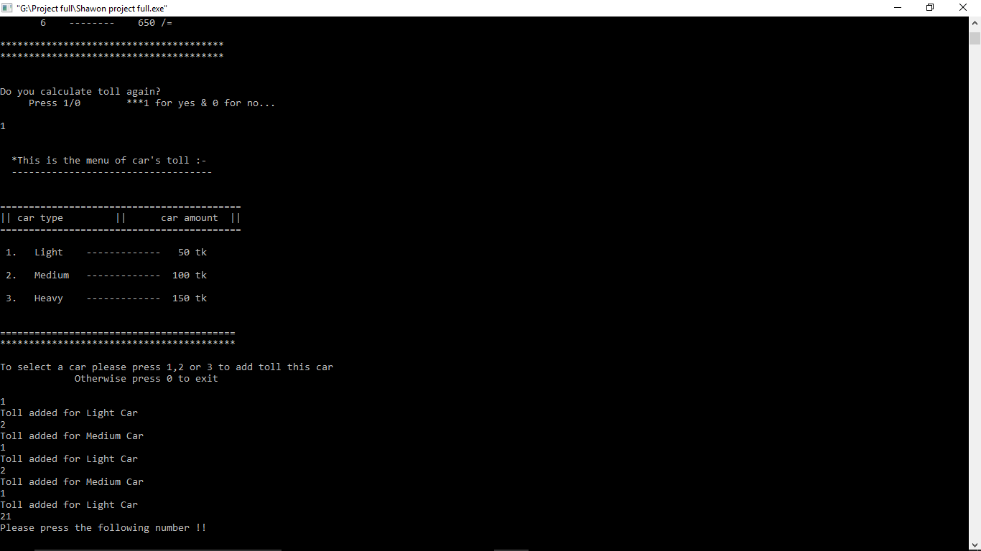

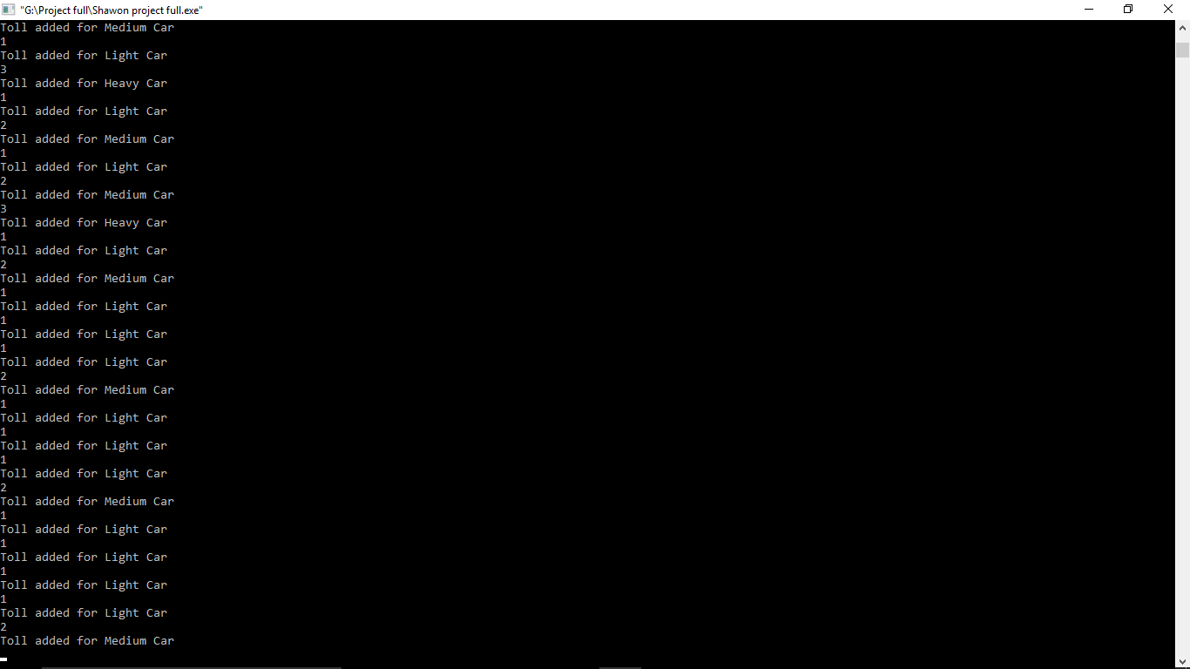

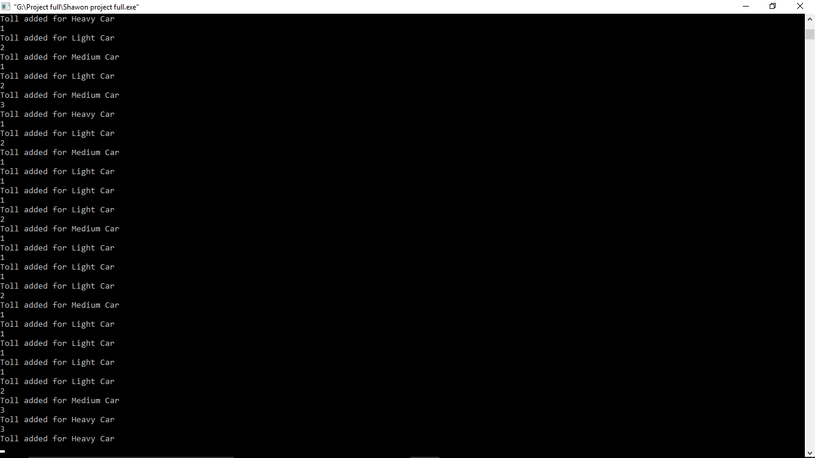

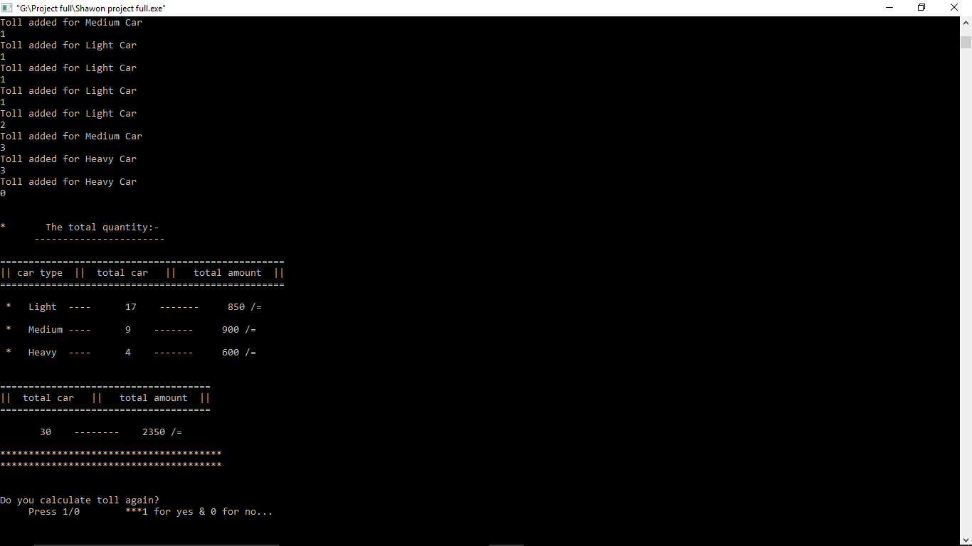

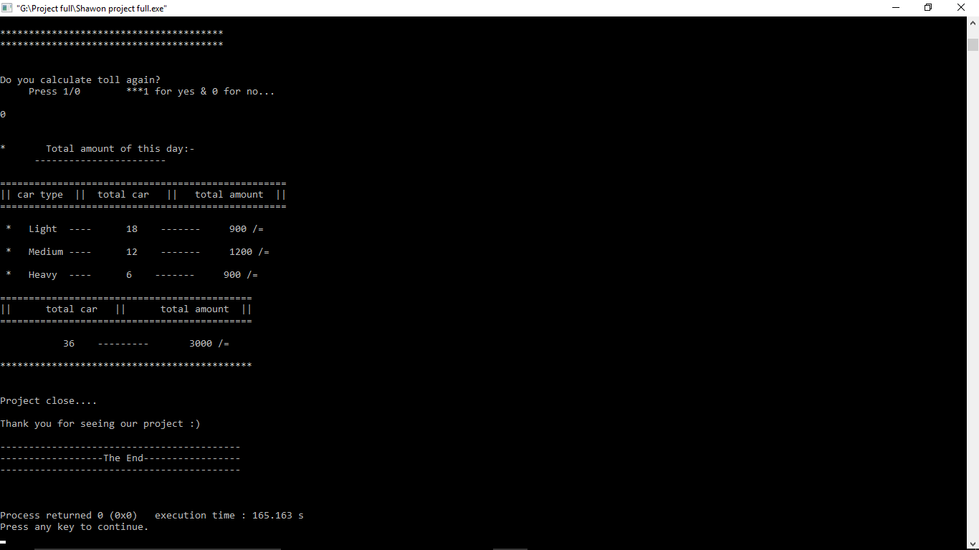

Upcoming Updates

This project is evolving everyday new features resulting interaction between the company and to our users. They provide feedback and suggestion we to the time to satisfy them. These are some features that we can show as hint…….

* + We want to add some other functions such that motion-sensor, voice-sensor & many other.
  + Add some function to they will need in in the future.
  + There will be an information center, if someone feel any kind of wrong then they discuss with us.

Conclusion

* Gives you satisfaction with you toll company service provider.
* Easily manageable & can be monitored by the authorities.
* Can be used with in all reach toll company.
* This system helps people save their time and give toll easily.
* Every toll company can use it for collecting their toll.

Reference

I saw this system when I was in class 9. On that time I have to go Jamuna-bridge for my school picnic. I show, it was large number of cars but the toll collecting system was very poor. It was like hand to hand collecting system. For this reason people lost their valuable time. On that time I don’t know how to make tool management code, but today is different. i know how to do it, thanks my university and my respected teacher,

**DR.Md.Moinul Islam.**